THE STRUCTURAL CHARACTERISTICS OF PRE-INDUSTRIAL ECONOMY
(Alfani-Colli, ch. 1–2.1)
Course: Economic History (30067) – A.Y. 2025/2026
Lecturer: Sonia Schifano

IN THIS CLASS
- Shift from hunting and gathering to agriculture
- Agricultural (Neolithic) revolution
- Urban revolution
- Structural features of agrarian societies
- Malthusian theory of population growth
- Accelerator of history: the Black Death

BEFORE THE INDUSTRIAL REVOLUTION
- Societies were agricultural: agriculture and animal husbandry formed the backbone of socio-economic structure.
- Significance of agriculture:
  - Foundation for settled societies
  - Surplus food production
  - Development of technology and specialization
- Agriculture changed environment and landscape decisively.
- Agriculture was an invention, not a given—one of the most important in human history.

THE AGRICULTURAL REVOLUTION
- Occurred in multiple regions (Middle East, China, India, West Africa, Mesoamerica, Andes, SE Asia).
- Domestication of species varied by region (wheat, barley, rice, maize, yams, bananas, etc.).
Why did it happen?
- Classical theory: humans “discovered” agriculture and adopted it.
- Recent view: demographic pressure forced adoption; techniques accumulated through observation.

SHIFT TO AGRICULTURE: A MIXED BLESSING
Pros:
- More food available
- Population growth
- Socio-economic complexity
Cons:
- Pressure on resources
- Less dietary variety → worse nutrition
- More diseases (due to proximity in villages)
Demographic impact:
- Population grew from ~6 million (10,000 BCE) to 6 billion (2000 CE).
- Life expectancy rose from 20 to 56 years.

FROM AGRICULTURE TO URBAN REVOLUTION
- Urban Revolution (3000 BCE):
  - Surplus food → stable communities → cities
  - Bronze Age: metallurgy, fortified cities, trade hubs, governance, cultural innovation
Pros:
- Division of labor
- Knowledge accumulation
- Complex socio-political structures
Cons:
- Higher taxation
- Increased inequality

PROTO-DIVERGENCE: WHY EURASIA?
- Institutional factors (Jack Goody):
  - Stronger state capacity
  - Private property recognition
  - Stricter inheritance systems
- Environmental factors (Jared Diamond):
  - More domesticable species
  - East-West axis → easier diffusion
  - Fewer natural barriers

FEATURES OF AGRARIAN SOCIETIES
- Low urbanization (6–8% in W. Europe; 20–25% in Italy pre-Black Death)
- Limited division of labor (age/gender-based)
- High self-consumption (~90%)
- Low productivity → limited surplus
- Strong solidarity (e.g., matrimonial strategies)
Technological progress (from 1000 CE):
- Heavy plow, collar harness, three-field rotation, water mills
- Technology (hardware & software) → higher labor productivity

ROLE OF CITIES & MARKETS
- Cities specialized in:
  - Manufactured goods
  - Trade
  - Services (civil, ecclesiastical)
- Markets promoted specialization and productivity (Adam Smith, 1776).
- Town-country complementarity essential for pre-industrial development.

CONSTRAINTS ON GROWTH: MALTHUSIAN THEORY
- Thomas Malthus, Essay on the Principle of Population (1798):
  - Population grows geometrically (2, 4, 8, 16…)
  - Food supply grows arithmetically (2, 4, 6, 8…)
  - Result: food shortage → poverty → checks on population
Checks:
- Positive: famine, disease, war
- Preventive: delayed marriage, moral restraint

ESCAPING THE MALTHUSIAN TRAP
- 18th century (England):
  - Agricultural modernization
  - Industrial Revolution
- Led to demographic transition (falling mortality, later falling fertility).

ACCELERATOR OF HISTORY: THE BLACK DEATH (1347–1352)
- Killed 30–60% of Europe’s population.
Pros:
- Less pressure on resources
- More land per capita
- Reduced inequality, higher mobility
- Improved living standards
Cons:
- Massive demographic decline
- Loss of human capital
- Collapse of trade and production
Long-term effects:
- Real wages rose (labor scarcity)
- Welfare ratios improved
- Population recovery slowly (took centuries)

KEY TAKEAWAYS
- Pre-industrial economies were agrarian, low-productivity, high self-consumption.
- Growth constrained by resource limits and demographic dynamics.
- Major accelerators: agriculture, urbanization, Black Death.
- Escaping from stagnation required technological progress, institutional change, and industrialization.

THE ‘GREAT DIVERGENCE’
(Alfani-Colli, ch. 2.2–3)
Course: Economic History – A.Y. 2025/2026
Lecturer: Sonia Schifano

IN THIS EPISODE
- From Closed Worlds to Open World
- The Great Divergence: How did Europe become so powerful?
- Reasons behind the European take-off:
  - Demography
  - Geography
  - Institutions
  - Geo-politics

PREINDUSTRIAL ‘CLOSED WORLDS’
- Until the end of the 13th century, Europe, the Mediterranean, East Asia, and Central America were closed worlds.
- Internal trade existed, but no global integration.
- 1450–1550: breaking point → geographical discoveries, new routes → world economic system emerges.
- Opening starts in Europe and the Mediterranean.

THE CENTRALITY OF THE MEDITERRANEAN
- Until late 15th century, European naval trade focused on the Mediterranean, dominated by Italians (Venice, Genoa).
- Imports from East: silks, porcelains, spices, alum, cotton.
- Exports to Levant: wool, linen, furs, metals, paper, glass.

THE FIRST ‘OPENING’
- Late 13th century: Genoa & Venice connect Mediterranean to Northern Europe by sea (spices ↔ metals, wool).
- Ships (galleys, cocche) unsuitable for ocean → Italians failed to reach Indies; Genoese expedition (1291) failed.

PREMISES OF DISCOVERIES: GUNS, SAILS & EMPIRES
- 15th century:
  - Caravels: sturdier, faster ships for ocean navigation.
  - Navigation tools improved: quadrant, astrolabe, nautical charts.
  - Cannons enabled military-backed trade.
- Portuguese, Dutch, Flemish aimed to enter Asian trade.

OPENING CLOSED WORLDS
- Portuguese integrated Mediterranean–North Sea trade, then looked south.
- 1434: Gil Eanes rounded Cape Bojador → geopolitical shift.
- Ottoman expansion hindered Italian trade → search for new routes.

THE AGE OF PORTUGUESE DISCOVERIES
- 1427: Azores discovered
- 1434: Cape Bojador rounded
- 1487–88: Bartolomeo Diaz → Cape of Good Hope
- 1497–98: Vasco da Gama → India (Calicut)
Portuguese strategy:
- Outposts for trade control (gold, ivory, spices, later slaves).
- Minimal territorial occupation, high resource extraction.
- Expansion to Malacca (1510), China (1513), Japan (1543).
- Displaced Genoa, Venice, and Arabs in Indian Ocean trade.

THE SPANISH EMPIRE
- After Reconquista, Spain financed westward expedition.
- 1492: Columbus discovered Americas (seeking Asia).
- 1520s: Cortés conquered American empires (fragile structures).

NEW GEOPOLITICAL ORDER
- Treaty of Tordesillas (1494): divided new routes between Spain & Portugal.
- Magellan-Elcano circumnavigation (1519–1522) proved Earth’s sphericity.

PROTO-GLOBALISATION (1435–1550)
- Integration of distant markets → global trade.
- Mercantilism:
  - Protectionism (tariffs)
  - Trade monopolies (e.g., East India Company)
  - Export incentives
  - Colonialism (raw materials, exclusive markets)

THE GREAT DIVERGENCE
- Process by which:
  - Europe became richest region
  - Broke limits of agrarian economies
  - Led to modern economic development (Industrial Revolution)
- Roots in preconditions & events.
- Until late Middle Ages, Asia & Europe had similar conditions; Asia often ahead in technology.

EXPLAINING THE GREAT DIVERGENCE
From 1500s, Europe diverged:
- Higher urbanization
- Maritime dominance, intercontinental empires
- Technological & scientific edge
- Better living standards
Three main explanations:
- Demography
- Institutions
- Geography & Geopolitics

1. DEMOGRAPHY
- Higher population density in Europe → faster idea circulation, innovation, resource pressure.
- Black Death (1347):
  - Reduced resource pressure
  - Temporarily broke Malthusian trap
  - Raised real wages, improved living conditions, reduced inequality
- G. Clark: divergence roots in Middle Ages.

2. INSTITUTIONS
- Douglass North: Institutions = rules of the game shaping incentives.
- European institutions fostered innovation:
  - Universities → knowledge dissemination
  - Mercantile cities → trade dynamism
  - Private initiative, property rights, efficient markets
- Landes, North, Needham: institutional advantage explains divergence.

3. GEOGRAPHY & GEOPOLITICS
- Europe: small states → competition & innovation
- Asia: large empires → stability over innovation
- Access to Americas → new resources, energy-intensive sectors (coal)
- Colonialism → Europe exploited colonies, creating core–periphery system (Wallerstein).

THE WORLD SYSTEM (WALLERSTEIN)
- Core: high-value production, economic dominance
- Semi-periphery: significant economic weight, limited political power
- Periphery: raw materials, low-value production
- Development & underdevelopment are interlinked in global capitalism.

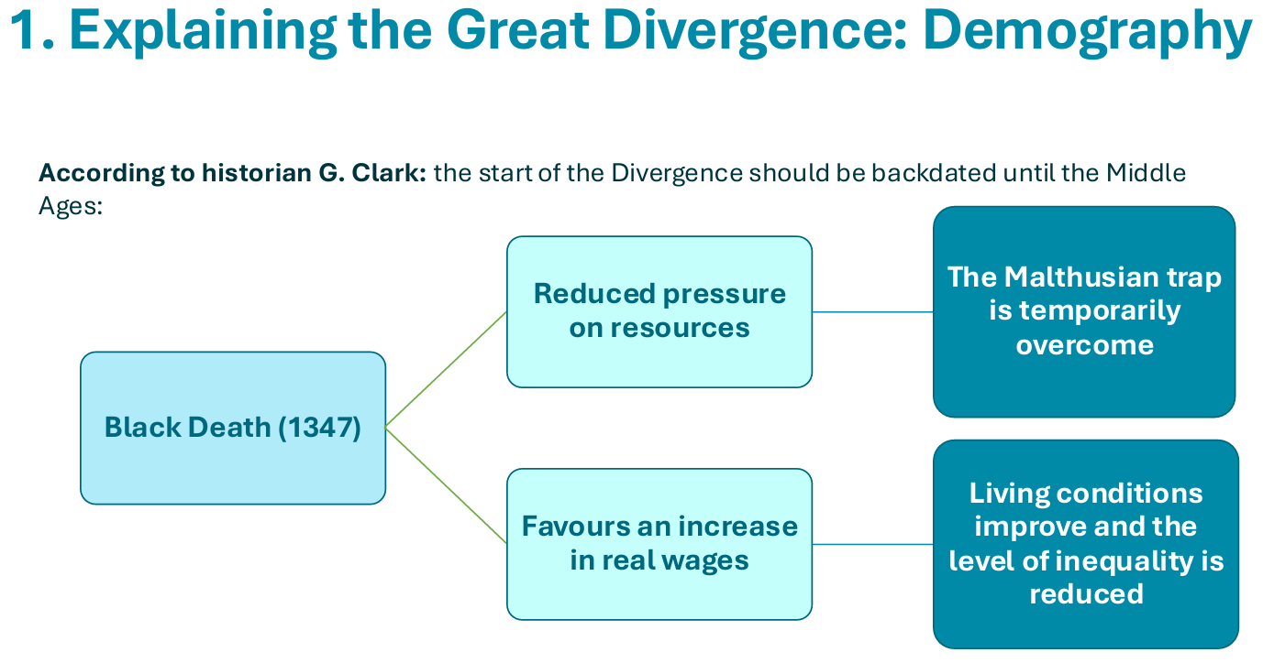
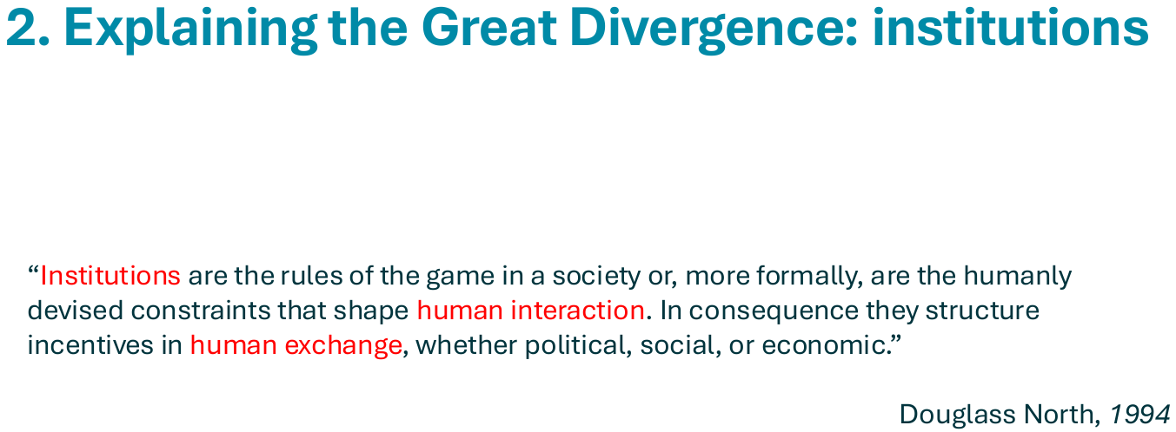
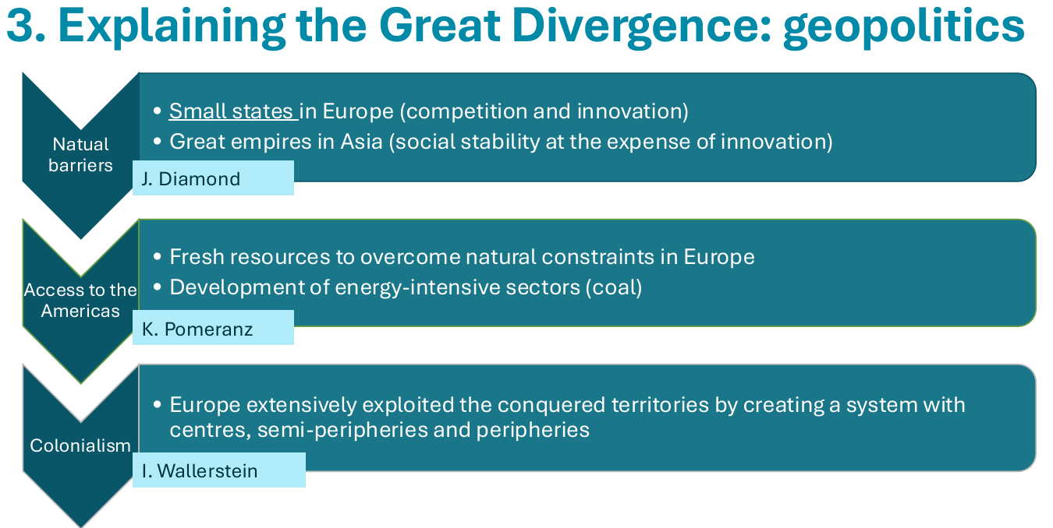
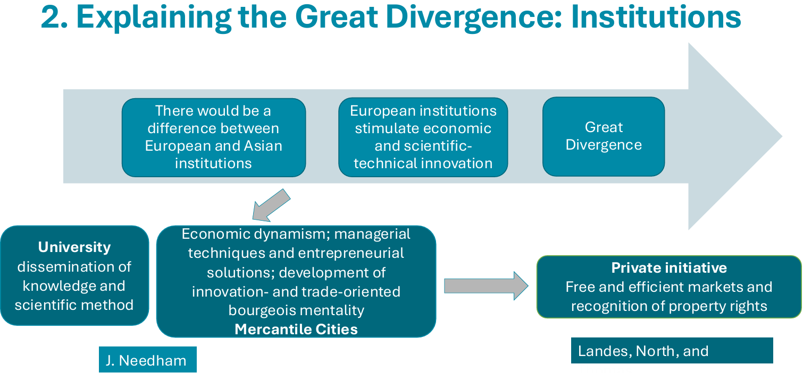

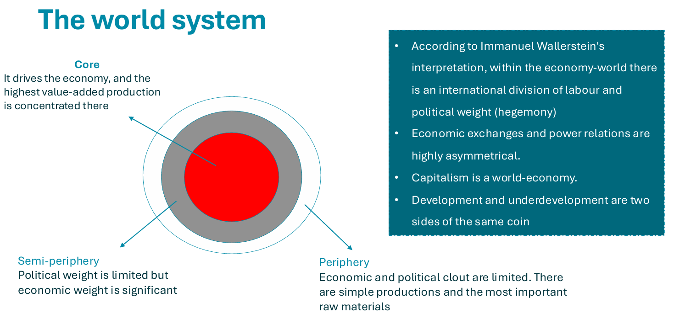

NEW PLAYERS, NEW INSTITUTIONS
(Alfani-Colli, ch. 4)
Course: Economic History – A.Y. 2025/2026
Lecturer: Sonia Schifano

IN THIS EPISODE
- What is the Little Divergence?
- Who are the main players?
- How historiography theorized this
- Why did the North Sea region overtake the Mediterranean?

THE LITTLE DIVERGENCE
- Refers to the growing economic gap within Europe (16th–19th century).
- Centre of gravity (economic, political, cultural) shifted northwards (Dutch Republic → England).
- Southern Europe declined relatively; process was long and complex, not sudden.

HOW DO WE MEASURE THIS SHIFT?
- Indicators:
  - Real wages (grams of silver) → North-Western cities outpaced Southern/Central Europe.
  - GDP per capita (1990 dollars): Holland & England surged; Italy, Spain stagnated.
  - Holland: GDP and population grew strongly (1540–1800).

THE MEDITERRANEAN CAME FIRST
- Until Middle Ages: Mediterranean (Italy: Florence, Genoa, Milan, Venice) was Europe’s most developed area.
- Mid-14th century: Venice = economic hub.
- Competitors: Hanseatic League, Flanders.
- Atlantic routes shifted core from Italy to Iberian Peninsula.

AND THEN THE BARICENTER WENT NORTH
- Despite Iberian empires, economic centre moved to Northern Europe.
- Antwerp became world economy hub:
  - Geographical position (Mediterranean–Baltic link)
  - Mercantile/manufacturing tradition
  - Financial centre
  - Under Spanish rule

WHY NOT THE IBERIAN PENINSULA?
Portugal:
- Limited resources; relied on Flemish merchants; faced English/Dutch competition.
Spain:
- Vast empire = high costs; wars of religion; Anglo-French rivalry; predatory colonial exploitation; gold & silver inflows → inflation.

THE RISE OF AMSTERDAM & THE DUTCH REPUBLIC
- Spanish bankruptcies + Wars of Religion → economic decline → revolt in Low Countries.
- 1581: Republic of Seven United Netherlands (recognized 1648).
- Antwerp under Spain → decline → Amsterdam rises as new economic hub.

DE JURE VS. DE FACTO POWER (Acemoglu & Robinson)
- De Jure: Legal/institutional power (e.g., voting rights, constitutional authority).
- De Facto: Practical power (e.g., military coups, lobbying).

THE FLYING DUTCH (REPUBLIC)
- High population density → innovation, knowledge exchange.
- Economy:
  - Market-oriented agriculture & manufacturing
  - Specialization
  - Commerce (local & international)
  - Services: shipping, banking, insurance
- Agriculture: horticulture, dairy, crop rotation
- Manufacture: textiles, colonial goods (sugar, tobacco), beer, weapons, paper
- Finance: Amsterdam Stock Exchange, Wisselbank (1609–1820) → world’s largest bank in 18th century.
- Culture: arts for bourgeoisie; religious tolerance.

TRADE & FINANCE
- Dutch dominated Baltic–Mediterranean trade (75% of goods).
- Amsterdam = Europe’s main trading & financial hub; influx of persecuted minorities (Jews, Huguenots).
- Lower transaction costs via dense networks.

INSTITUTIONS: JOINT-STOCK COMPANIES
- Spain/Portugal: royal monopoly on overseas trade → inefficiency.
- Dutch: delegated trade & governance to private joint-stock companies:
  - VOC (1602): monopoly on Asian trade
  - WIC (1621): monopoly on Atlantic trade; occupied Brazil (1630–1654)
- Companies could sign treaties, maintain armies, govern territories.

COMMERCE & COLONIALISM
- Dutch model adopted by England & France:
  - Dutch: trade focus
  - English/French: territorial control
- England overtook Dutch in 18th century via wars (1652–1674) & Navigation Acts (1651).
- Seven Years’ War (1754–1763): England defeats France → colonial dominance → sparks American independence (1783).

HOW TO INTERPRET THE LITTLE DIVERGENCE?
No single cause → multiple intersecting factors:
- Geography: Atlantic access + open institutions favored Northern Europe.
- Demography:
  - Hajnal & Clark: late marriage, high fertility of elites, inheritance patterns → mobile labor force.
  - Alfani: plague (1629–30) devastated Italy → stagnation.
- Social Institutions:
  - European Marriage Pattern → women in labor market → Industrious Revolution (De Vries) → precursor to Industrial Revolution.
- Economic Institutions:
  - Guild rigidity in Southern Europe vs. flexibility (putting-out system) in North.
- Political Institutions:
  - Secure property rights (North, 1973); advanced citizenship rights (Prak & van Zanden); parliamentarization (North & Weingast, 1989).
- Cultural Institutions:
  - Open political systems → social mobility, entrepreneurship (Acemoglu et al.).
  - Weber: Protestant ethic fostered capitalist attitudes.

THE INDUSTRIAL REVOLUTION – PRE-CONDITIONS
ALFANI COLLI, CH. 5
Economic History – A.Y. 2025/2026
Sonia Schifano

IN THIS CLASS
- Preconditions
- Factors of the IR
- Market oriented economy
- The role of the State
- Resources
- Technology
- Sectors: Textile, Energy
- Why Britain?
- Obstacles: advantage or disadvantage?

BREAKING POINT WRT PAST
- Shift from specialization and trade → investment and technological progress
- Atlantic trade routes → more non-agricultural population
- Population growth → need for food surplus → allows non-agricultural production
Key dimensions: Technical, Political, Institutional, Technological, Geographical

THE AGRICULTURAL REVOLUTION (1400–1700)
- High wages economy sustained demand for goods
- Better food (dairy, meat) → shift from grain to livestock
- More draft animals → more power & manure → higher productivity → higher wages
Result: Increase in output per worker (Agricultural labor productivity)

INCREASE IN OUTPUT PER WORKER
How did farmers increase productivity?
- Increased capital intensity (draft animals)
- Increased land per worker
- Improved techniques and soil quality
Allen (2000): Agricultural labor productivity in Europe (England 1800 = 100)
(England rose from 53.1 in 1600 to 100 in 1800; Netherlands and Belgium also high; Italy and Spain declined)

MARKET ORIENTED ECONOMY
From Open Fields to Enclosures
- Before Black Death: open-field system (narrow strips, communal)
- 1500: 45% enclosed → 1750: ⅔ enclosed → 1760–1830: Parliamentary enclosures
- 18th century: consolidated landholdings rented to capitalist farmers
Why enclosures?
- Open fields inefficient: no incentive to invest
- Enclosed fields: economies of scale, tenant investment, long leases

THE PROCESS
Traditional view:
Enclosures → less farm labor → more food surplus → urban growth → specialization & trade
Allen’s alternative:
Urban growth → higher food prices & urban wages → capital into agriculture → enclosures → innovation

THE ROLE OF THE STATE
Mercantilism & Empire
- Goal: export more, import less → wealth accumulation
- Policies: strengthen colonial trade, naval dominance, domestic production
- Navigation Acts (1651, 1660, 1663): British ships only, colonial trade restrictions
- Staple Act (1663): colonies buy only from Britain → tensions → American independence
Institutions
- Civil War (1642–49), Glorious Revolution (1688–89) → inclusive political system
- Strengthened property rights, financial systems, trade expansion

RESOURCES
Coal
- Britain had abundant coal → early mining → shift from wood to coal (timber crisis)
- Coal mining increased 66-fold (1560–1800)
- Enabled cheap energy economy → steam engine, iron & steel, railways

TRANSPORT REVOLUTION
- Lowered transaction costs (–40%), travel times (–60%)
- Turnpike roads (financed by tolls), canals → integrated markets

TECHNOLOGY
- Macro-inventions (1760–1820): steam engine, spinning machines, puddling process
- Micro-inventions (1820–1850s): incremental improvements
- Second Industrial Revolution (1860s–): electricity, chemistry
Nature of innovation:
- Inspiration (science, luck) + Perspiration (R&D, incentives)

TEXTILE INDUSTRY
- Cotton industry: from minor (1780) to largest sector (1830)
- Lancashire: industrial hub (coal, water, port access, agglomeration effects)
- By 1851: 66% of UK spindles, 46% of world spindles

MINING & STEAM POWER
- Coke smelting → iron industry
- Steam engines for pumping water in mines → later rotary motion (James Watt)

WHY BRITAIN?
- Market economy, property rights, strong but limited state
- Geography: coal, water, sea access
- Skills in textiles, mining, iron
- Agriculture reorganized on capitalist lines

THE BREAKING POINT
- Continuous population growth
- GDP & GDP per capita growth
- Productivity & TFP increase
- Structural change: decline of agriculture
- Social & cultural change: commoditization of land, labor, capital
- Global market formation

GDP PER CAPITA (1990 dollars)
Britain: 1500 → \$762; 1700 → \$1,405; 1820 → \$2,121; 1913 → \$5,150

CULTURE & ENLIGHTENMENT
- Scientific Revolution → Enlightenment → institutions promoting science
- Mokyr: Enlightenment boosted innovation via knowledge diffusion, patents
- Industrial Revolution = first cluster of inventions leading to continuous progress

COMPLEMENTARITY OF MICRO & MACRO INVENTIONS
- Stage 1 (1760s–1820s): limited progress, modest productivity
- Stage 2 (1830s–1870s): mechanization, steam transport, telegraph, chemistry → fast growth

SUMMARY
- Industrial Revolution = radical economic & social transformation
- Driven by: agriculture, state, resources, technology, culture
- Britain led due to unique combination of geography, institutions, and innovation

FROM THE SPREAD OF IR TO THE SECOND IR
(Alfani-Colli, ch. 5.3 and 6)
Course: Economic History – A.Y. 2025/2026
Lecturer: Sonia Schifano

IN THIS CLASS
- When and how industrialization spreads (regional factors)
- When industry does not take off on its own
- The role of universal banks
- The role of the State
- Gerschenkron theory
- Pollard theory

THE LONG WAY TO INDUSTRIALISATION
- England initially restricted technology transfer, but:
  - 1824: craftsmen allowed to emigrate
  - 1825: could produce machinery abroad under license
  - 1843: free trade → no restrictions on labor movement
- Spread of English production systems across Europe.
First adopters: Belgium, Alsace, Rhineland, Northern France, Switzerland, Saxony, Bohemia, Lombardy → due to mercantile networks & manufacturing tradition (esp. textiles).

POLLARD THEORY
- Industrialization spread regionally, not nationally.
- Homogeneous areas (resources, human capital) developed faster.
- Institutional differences → varied speeds & characteristics.
- Contemporaneity differential: global developments affect national plans (e.g., railways: GB followed industry; France/Germany/USA promoted it; Italy wasted resources).

RAILWAYS AND ECONOMIC GROWTH
Why important?
- Economic impact: demand for coal, iron, steel → growth of mining, metallurgy, engineering.
- Social impact: mass travel → urbanization, cultural exchange.
- Global impact: tool for imperialism (India, Africa).

BELGIUM
- First to adopt British model:
  - Institutions, proximity, industrial tradition (cotton, linen), commerce
  - State-built railways (1830), canals, mining
  - Attracted French capital

FRANCE – THE FRENCH PARADOX
- Backwardness with phases (1700–1850)
- Low demographic growth
- French Revolution, Napoleonic Codes
- Coal scarcity (30% imported)
- Small-scale, water-dependent enterprises
- Textile exports, food self-sufficiency

THE SECOND INDUSTRIAL REVOLUTION
THE DOUBLE LEAP
- Latecomers faced two challenges:
  - Catch-up in First IR sectors (textiles, coal, iron)
  - Invest in Second IR sectors (capital-intensive, tech-driven)

PILLARS OF THE SECOND IR
- Science applied to production → R&D
- Big business & new organizational structures
- Capital-intensive sectors
- US overtakes GB as global leader
Features:
- Greater capital intensity
- Strong science-technology link
- Multiple sectors innovating
- Industrial R&D labs emerge
- Faster growth than First IR

KEY TECHNOLOGIES & INDUSTRIES
- Steel:
  - 1856 Bessemer process
  - 1856–67 Martin-Siemens
  - 1878–79 Gilchrist Thomas
- Chemicals: dyes, fertilizers, pharma, explosives, synthetic fibers (Germany leads via university-industry cooperation).
- Electricity: motor, dynamo (1820s–30s), telegraph (1840s–60s), power grids (1880s).
- Internal combustion engine: Daimler, Benz, Diesel (1880s–90s).
- Food processing: canning (USA, 1860s), refrigeration.
- Light mechanics: typewriter, sewing machine.

TRANSPORT & COMMUNICATION REVOLUTION
- Telegraph (1840), transatlantic cables (1860), telephone (1870)
- Steamships, railways
- Suez Canal (1869), Panama Canal (1881)
→ Lower transport costs, integrated national & global markets

RISE OF BIG BUSINESS
- Economies of scale
- Vertical integration
- Managerial hierarchies
- Oligopolies, multinationalization
- Dualism: advanced vs traditional sectors
Work organization:
- Victorian factory → department heads
- Modern factory → professional managers
- Innovators: Taylor (scientific management), Ford (assembly line), Bedaux, Ohno

TAYLORISM
- Best method identification
- Worker selection & training
- Division of labor
Goal: efficiency → profit

FORDISM
- Standardization & economies of scale
- Assembly line → minimal skills needed
- High wages + welfare + anti-union stance

GERSCHENKRON MODEL – ADVANTAGES OF BACKWARDNESS
- Backward nations can skip R&D → imitate leaders
- Leads to:
  - Faster growth
  - Large-scale industry
  - Less agricultural growth
  - Greater role of institutions
  - Dependence on foreign capital
- Substitute factors: state intervention, universal banks

UNIVERSAL BANKS
- Continental Europe: universal banks (joint-stock) → commercial + investment services
- Risk: liquidity crises

ROLE OF THE STATE
- Protectionism
- Fiscal tools
- State contracts, subsidies
- Infrastructure financing
- Industrial bailouts

COUNTRY CASES
Germany:
- 1834–70: imitation → modern industry
- Post-1870: Western Europe’s leader
- Strength: coal, steel, chemicals, electricity
- Large firms, cartels, protectionism
Italy:
- Post-unification: need for standardization
- 1870s–90s: textiles, railways, tariffs
- 1896+: hydroelectric power, Fiat, metallurgy, chemicals
- Uneven growth → “Industrial Triangle” (Milan–Turin–Genoa)
- Mass emigration → remittances, export networks

THE SOCIAL ASPECTS OF THE INDUSTRIAL REVOLUTION
(Alfani-Colli, ch. 7)
Course: Economic History – A.Y. 2025/2026
Lecturer: Sonia Schifano

IN THIS CLASS
- Structural change in society
- Modern Economic Growth and Demographic Transitions
- Effects
- Living standards
- Examples

SOCIETY AND THE IR
- Old Regime: nobility, clergy, common people
- Classes:
  - Nobility: living “nobly” without working
  - Haute bourgeoisie: merchants, professionals
  - Petite bourgeoisie: artisans
  - Peasants, domestic workers, indigents
- End of 18th century → IR: middle class becomes leader
- Abolition of feudalism (Napoleonic Code) → full property rights
- Land confiscated from Church → sold
- Shift from land aristocracy to industrial aristocracy → power moves from nobility to bourgeoisie

MODERN ECONOMIC GROWTH (Kuznets)
Definition: Long-term rise in capacity to supply diverse goods, based on technology and institutional change.
Six characteristics:
- High per capita product & population growth
- Rising productivity
- Structural transformation of economy
- Social & ideological change
- Developed countries lead
- Limited global spread
Transition:
- 18th century: slow growth, high fertility, low education
- Post-1870: dynamic growth, tech progress, rising education, declining fertility
Origins:
- IR → higher productivity, wages, education demand
- Demographic transition → lower fertility, better living standards

KUZNETS CURVE & INEQUALITY
- Workforce shifts from low-income agriculture to high-income industry/services → inequality rises until ~50% transition, then falls.
- Wealth Gini (1820–1920): high inequality during early IR, later decline.

URBAN GROWTH PARADOX
- Productivity growth ≠ immediate wage rise
- Income concentration, decline of crafts, child labor
- Urban penalty: poor housing, sanitation → health crises
- Factory system: harsh discipline, “dark satanic mills”

LIVING STANDARDS & HEALTH
- CO₂ & water pollution, lack of sewers → cholera (1831)
- Air pollution → respiratory diseases, TB
- Overpopulation & poverty → political agenda → public health reforms (late 19th c.)
- Long run: improved health, higher life expectancy

ENVIRONMENTAL IMPACT
- CO₂ emissions per capita rose sharply (1820–2000).

KNOWLEDGE & EDUCATION
- Science-industry complementarity
- Education reforms:
  - UK: Factory Act (1833), Forster Act (1870), compulsory by 1891
  - France: free public education post-1840
- Literacy rates (1850 → 1900):
  - Sweden 90→99%, UK 67→96%, France 55→83%, Italy 20→52%, Russia 5→28%
- Primary school enrollment (per 10,000): US & Germany lead; Italy & Russia lag

LIVING STANDARDS DEBATE (Mokyr)
- Optimists: noticeable improvement after 1815
- Pessimists: little improvement before 1850
- Moderates: modest gains, slow for working class
- Issues: data limits, wars, epidemics, changing consumption
- Real wages ≠ full proxy; biological indicators (height, mortality) better
- HDI combines economic, biological, social indicators
Counterfactual:
- Even if conditions didn’t improve much pre-1850, IR prevented catastrophic decline amid population growth & shocks.

AN UNSTOPPABLE PROCESS
Alfani-Colli, chapters 6.4 and 8.2+8.3
Economic History – AY 2025/2026
Sonia Schifano

INDUSTRIALIZATION BEYOND EUROPE: USA
- At the time of independence (1783) – The Constitution took effect in 1789
- Almost 90% of the population worked in agriculture
- Between 1820–1860, the cotton industry became the largest global supplier of raw material
- The large domestic market boosted mass production industries
- In the first half of the 19th century:
  - States, municipalities, and private investors-built turnpikes and canals to integrate the internal market
  - By 1840, the U.S. railway network exceeded Europe’s, boosting transportation and industrial sectors (iron and steel)

USA: Economic Expansion
- Population grew from 4 million in 1790 to 40 million by 1870
- Income and wealth increased
- Labor scarcity relative to land and resources → higher wages and living standards
- Political and religious liberties
- Resource abundance explained high per capita income, but not necessarily faster economic growth compared to Western Europe
- Rapid technological progress
- Regional specialization due to large territory and varied climates

THE US ECONOMY (Civil War Era)
- Northeast: manufacturing, commerce, finance
- West: livestock farming, wheat, maize, cereals
- South: colonial products (cotton, sugar cane, tobacco) for export

USA: Industrial Leadership
- By 1880, non-agricultural labor force surpassed agricultural
- Manufacturing income exceeded agricultural income
- By 1890, USA was the most industrialized nation
- Rise of big corporations with central offices
- Integration of production and distribution
- Multinational expansion
- Universities began offering engineering courses
- Business schools emerged to study corporate strategy and management

USA: Share of World Industrial Output (%)
(From W.W. Rostow, The World Economy: History and Prospect, 1978)
- 1870, 1899, ca. 1913: USA’s share increased significantly compared to Italy, France, Germany, UK, and rest of the world

TAYLORISM (Scientific Management)
- Developed by Frederick Taylor (1911)
- Key principles:
  - Identify best methods
  - Select and train personnel
  - Divide labor and management tasks
- Goal: increase efficiency and profit

FORDISM
- Ford’s method improved on Taylorism
- Workers didn’t need training—tasks were simplified
- Emphasized standardization and economies of scale
- Assembly line design minimized movement and skill requirements
- Combined with:
  - High wages
  - Corporate welfare
  - Anti-union stance

INDUSTRIALIZATION BEYOND EUROPE: CHINA
- Qing Dynasty: Manchu conquered Beijing in 1645
- Population grew from ~275 million (1700) to ~350 million (1800)
- Agricultural economy
- Exported tea and silk to Britain
- British goods not in demand → Britain paid in Mexican silver
- Later replaced silver with opium from Bengal
- Opium harmed public health and trade balance
- Led to corruption and administrative disorder

CHINA: Opium Wars & Aftermath
- Opium Wars (1840, 1860) and Unequal Treaties
- China ceded Hong Kong to Britain
- Opened 5 new ports
- Paid indemnities
- Other Western nations gained favorable terms
- Government weakness led to anti-government and anti-foreign protests
- Boxer Rebellion (1900–1901)
- Students studying abroad (esp. Japan) criticized traditional society
- Sun Yat-Sen’s 1912 revolution → Republic of China
- Political instability delayed industrialization

INDUSTRIALIZATION BEYOND EUROPE
- Public intervention was crucial in early industrial transformations outside Europe
- Began around the turn of the 19th–20th centuries due to globalization and external shocks

INDUSTRIALIZATION BEYOND EUROPE: JAPAN (Tokugawa Period)
- Tokugawa Japan (1603–1868) was isolated (sakoku)
- Foreign trade limited to Koreans, Dutch, and Chinese via Nagasaki
- Modernizing trends included:
  - Urban development
  - Luxury handicrafts
  - Production models like European putting-out system
  - Rice trade and credit circuits
  - Widespread primary education
  - Good road network → regional market integration

JAPAN: Forced Opening
- 1853–1854: US military forced Japan to open trade
- Unequal treaties followed:
  - Extraterritoriality for foreign merchants
  - Tariffs capped at 5%
- Western competition harmed Japanese industries

JAPAN: Meiji Restoration (1868)
- Emperor Mutsuhito replaced the shogunate
- Goal: become a “first-class nation” (fokoku kyohei = rich nation, strong army)

JAPAN: Modernization Program
- Inspired by Western models
- Reforms included:
  - Administration
  - Armed forces
  - Tax system
  - Education
  - Company law
  - Infrastructure
  - Credit and banking
  - Adoption of gold standard

JAPAN: Copying the West
- Imported technology
- Hired foreign experts
- Sent missions abroad (e.g., Iwakura Mission to US and Europe)

JAPAN: Industrial Strategy
- Meiji government-built infrastructure (esp. railways)
- Established state-run industries: shipbuilding, iron & steel, weapons, chemicals, sugar, glass, textiles
- Later sold to private sector → formation of zaibatsu (industrial conglomerates)
- Used import substitution policy: tariffs to protect domestic industry

Major Zaibatsu Groups
- Mitsubishi
- Mitsui
- Sumitomo

Global Economic Growth Data (1000–1998)
(Source: A. Maddison, The World Economy: A Millennial Perspective, 2007)
- Annual average compound growth rates for per capita GDP, population, and GDP across regions
- Highlights rapid growth in Japan post-1950 and slower growth in Africa and Eastern Europe post-1973
Here is the complete extracted and formatted text from the presentation “9_the first phase of globalisation.pdf”, organized by topic for clarity:

THE FIRST GLOBALIZATION
Alfani-Colli, Chapters 9.1–9.2
Economic History – AY 2025/2026
Instructor: Sonia Schifano

Overview of Topics
- How to define globalization
- The four pillars of globalization:
  - Economic integration
  - Transport and communication
  - Trade policies
  - Gold standard
- Globalization and migrations
- Globalization and imperialism

Definition of Globalization
Globalization is a process of political, economic, social, and cultural integration characterized by the rapid and easy transfer of:
- Goods (international trade)
- Capital (international investments)
- Knowledge
- People (migration)
It is not spontaneous—it depends on:
- Technological advancements
- Political decisions
Note: Globalization is reversible.

Types of Globalization
- Soft (Proto) Globalization:
Began in 1571 with the connection between the Old World and the Americas via Manila.
Characterized by limited interaction and slow transportation.
- Hard Globalization:
Occurred during the 19th century with market integration across space.

Soft Globalization Characteristics
- Expansion of global connections (Silk Road, Africa, Americas, Asia)
- Exchange of goods, ideas, and food (e.g., potatoes supported population growth)
- Labor mobility
- Limited by slow transport and high costs

Hard Globalization (1850–1914)
- Driven by the Industrial Revolution
- Mass production of household items
- Rapid population growth increased demand
- Lower transport costs
- Faster movement of goods and people
- Enhanced communication
- Emergence of international capital and foreign exchange markets
- Growth of stock exchanges (London, Paris, Amsterdam, Frankfurt)

Pillars of Globalization
1. Economic Integration
- Price convergence occurs only with market integration
- In pre-industrial economies, price fluctuations were local and natural (e.g., droughts)
- With industrialization, fluctuations became cyclical and trade-driven
- National economies synchronized → systemic crises
- Law of one price emerged
- Increased mobility of goods, labor, and capital
Capital Movement Factors:
- Peace
- Gold standard
- Raw materials in target countries
Forms of Capital Flows:
- Portfolio investments (stocks, bonds)
- Foreign direct investments (FDI)
Key Period:
1896–1914 known as “The Golden Age of Global Capitalism”

2. Transport and Communication
- Revolution in transport: trains, steamships
- Major infrastructure: Suez Canal (1859–69), Panama Canal (1881)
- Decline in transport costs
- Creation of national and international markets
Communication Advances:
- Telegraph (1840)
- Transatlantic cables (1860)
- Telephone (1870)
Quotes:
- Queen Victoria (1858): Celebrated the transatlantic cable as a tool for peace and progress
- John Maynard Keynes: Described global consumer access from London

3. Trade Policies
Economic Theories Supporting Free Trade:
- David Ricardo (1819): Comparative advantage
- Adam Smith (1776): Division of labor
- John Stuart Mill (1848): Market efficiency
England’s Trade Policy Evolution:
- Initially mercantilist and protectionist
- Shifted to free trade in mid-19th century
Corn Laws (1815–1846):
- Protected agriculture during Napoleonic Wars
- Repealed after Irish famine (1845)
- Navigation Acts repealed in 1849
- Customs revenue increased despite lower tariffs
Free Trade Advocacy:
- Promoted peace and individual action
- Richard Cobden led the Anti-Corn Law League
Cobden-Chevalier Treaty (1860):
- France lifted restrictions on British goods
- Duties capped at 30%
- Britain removed duties on manufactured goods
- Introduced the Most-Favored-Nation (MFN) clause
- Trade increased 10% annually
- Boosted competition and efficiency
Multilateral System:
- MFN clause led to stable, long-lasting trade treaties

3. The Great Deflation (1870s–1890s)
Causes:
- International competition
- Overproduction
- Influx of cheap non-European goods
Effects:
- Demand for protectionism
- Return to protective tariffs

3. Protectionist Theories
Key Thinkers:
- Alexander Hamilton (1791): Supported protection for manufacturers
- Friedrich List (1837): Advocated temporary protection for developing nations
- John Stuart Mill: Supported protection for young industries
List’s Vision:
- Liberalism as a tool of dominance
- Free trade not universally valid
- Protectionism as a path to industrialization
- State as organizer of economic policy
Protectionist Policies in Europe:
- Germany (1879): Tariffs for industry and agriculture
- France (1881, 1892): Industrial and agricultural protection
- Italy, Austria-Hungary, Russia: Protectionist bloc
- UK, Netherlands, Belgium, Denmark: Free trade bloc
Note: Protectionism did not halt international trade.

4. Gold Standard
Reasons for Adoption:
- Need for a stable monetary system
- Dominance of British trade and capital
- Pound sterling as global currency
- Global presence of British banks
Principles:
- Banknotes convertible to gold
- Free movement of gold
- Fixed exchange rate (gold parity)
Adoption Timeline:
- Germany (1871)
- Netherlands, Switzerland, Belgium (1873–78)
- France and Italy (1880s, under bimetallism)
- Russia and Japan (1890s)
- USA (1900)
Mechanism:
- Money supply tied to gold reserves
- Trade surplus → gold inflow → price rise → reduced competitiveness → trade balance restored
Benefits:
- Price stability
- Symmetry among countries
- Confidence in fixed exchange rates
- Commitment to return to parity after deviations
Limitations:
- Monetary policy constrained
- Only two of three goals possible: fixed rates, capital mobility, policy autonomy
Risks:
- Uneven experiences between core and peripheral countries
- Transmission of crises
- High resource costs
- Inadequate gold supply
- Price level swings
- Rule violations and lack of cooperation
Historical Perspectives:
- 1920s: Stability and harmony
- 1940s: Trade growth
- 1960s: Symmetric adjustment
- 1980s: Discipline and low inflation

Globalization and Migrations
Drivers:
- Increased flow of goods and capital
- Population growth (243% from early 19th century to WWI)
- Declining mortality, fewer famines and epidemics
- High birth rates → demographic transition
Effects:
- Labor market congestion
- Migration networks and hospitality
- Technological advances (iron passenger ships)
- Legislative support (barrier removal)
Consequences:
- Wage equalization between origin and destination countries
- Reduced demographic pressure in emigration countries
- Remittances improved balance of payments and domestic markets
- Formation of an international labor market

Globalization and Imperialism
Characteristics:
- Search for raw materials and markets
- Outlet for industrial production and population surplus
- Rise of multinational enterprises
- Need to invest surplus capital
- Political and ideological motives: national identity, power, superiority

The Scramble for Africa
- A major imperialist expansion driven by economic and political motives during the first phase of globalization.

